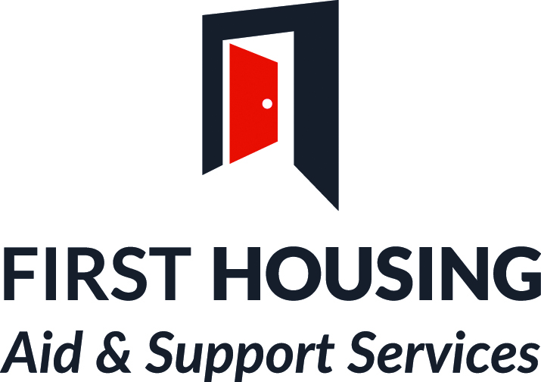

FIRST HOUSING AID & SUPPORT SERVICE PRIVACY NOTICE

Privacy Notice

First Housing Aid & Support Services (FHASS) is committed to protecting your privacy and maintaining your trust and confidence in how we handle your personal information. In this privacy notice we have provided as much information as we can on when and why we collect your personal information, what we do with it and the limited conditions under which we may disclose it to others.
We have a Data Protection Officer who will monitor our compliance with the data protection legislation. For further details on how your information is used, how we maintain the security of your information and your rights to access information we hold can be found at www.first-housing.com , you may write to: Senior Management at First Housing Aid & Support Services 26 Bishop Street L’ Derry BT48 6PR.

Table of Contents Page Number

Table of contents 2
What is personal data? 3
What is special category data? 3
Why we need your personal information. 3
What personal information we collect? 4
When do we collect your personal information? 4
How the law allows us to use your personal information. 5
How long we keep your personal information 6
Who we share your personal information with 6
What are your rights? 7 – 8
How to make a complaint. 9
Links to other websites 9
Changes to Privacy Notice. 9

What is personal data?
Personal data is anything that identifies or relates to a living person either by itself or when put together with other information. For example, this could be your address and car registration.
What is special category data?
Special category data is sensitive personal information, for example, details about your physical or mental health or sexuality. This type of personal information needs more protection.

Why we need your personal information
We need to know your personal information so that we can:
- Assess and determine your elegibility to access our services through referral processes or direct access.
- Assess and determine your housing needs under homelessness
- Facilitate the provision of Temporary Accommodation under Homelessness.
- Provide advice, assistance, and support within accommodation or in the community.
- Link you with appropriate specialist agencies based on you holistic risk and needs assessment
- Receive and process rent, service charges, other payments and to pursue arrears.
- Provide a repair, maintenance, service based on you identified needs
- Investigate complaints and anti-social behaviour.
- In participation with you help you to apply for housing benefit.
- Assess and administer applications to Funding bodies such as City Council Big Lottery Children in Need and others dealing with homelessness and deprivation.
- Administer and manage Supporting People funding.
- Carry out research in relation to any of our functions.
- Perform equality monitoring
- Meet our legal obligations to our funding bodies

If you do not provide the personal information we need, this may impact on our ability to carry out our functions and to provide our services to you, for example, you may not be able to obtain accommodation with us, receive help and housing advice in relation to preventing homelessness, or obtain housing benefit.
Where we can, we will only collect and use personal information if we need it to deliver a service or meet a requirement. If we do not need your personal information we will not ask you for it. We will anonymise your personal information for research purposes.

What personal information we collect?
We collect the following personal and special category information across the range of services we provide:
Name | Address
Date of Birth | National Insurance Number
Sex | Telephone Number/Mobile
Employment Details | Email Address
Education Details | Marital Status
Household Members details | Medical Details
Race Ethnic Origin Sex Religion Nationality Sexuality | Criminal Convictions

When do we collect your personal information?

We collect personal information:
- When a person applies for accommodation with us
- When a person presents as homeless.
- When a person contacts us about accessing floating support services to prevent homelessness
- Provide Homelessness advice and assistance
- To assist us to determine your rights and entitlements
- Receive and process rent, service charges, other payments and to pursue arrears.
- Provide a repair, maintenance, service.
- Assist with housing benefit applications
- Applications to Funding bodies such as City Council Big Lottery Children in Need for small pockets of deprivation
- Assess and administer applications to Funding bodies such as City Council Big Lottery Children in Need and others dealing with homelessness and deprivation.
- To assist us to administer and manage Supporting People funding.
- Carry out research in relation to any of our functions.
- Perform equality monitoring
- Meet all legal obligations to our funding bodies
- When we receive and investigate complaints.
- When we receive and investigate reports of anti-social behaviour.
- Where we use CCTV in our office locations.
- When we carry out equality monitoring.
- When we seek legal advice relating to any of the above circumstances

How the law allows us to use your personal information

The law allows personal information to be collected and used for six legal reasons.
Before the change in data protection law on 25 May 2018 we collected and used personal information mainly by consent. However, as a voluntary organisation the majority of our functions is governed by housing related legislation, so we will instead be processing personal information on the basis that it is necessary for us to carry out a function for legitimate business reasons to deal with a housing need or prevent homelessness.

This legal reason for processing personal information is known as Public Task. Public Task also allows us to process personal information where it is based on a statutory task and in the public interest, i.e. to help mitigate against homelessness and prevent it where we can. We are funded by the Northern Ireland Housing Executive and as such we are helping them carry out their public task as the regulated body in Northern Ireland dealing with homeless prevention.

The other legal reasons for which we process personal information are:
Where it is necessary for compliance with legislation - for example, where we are obliged to provide monitoring information to the Equality Commission for Northern Ireland to enable us to comply with our obligation towards equality monitoring, or to fulfil compliance with Health and Safety Legislation.
Contract - where you have entered into a contract with us, for example the
provision of accommodation with support. In this instance you have entered into an agreement with us to help you address your housing related needs. To fulfil our obligation to you we will need personal information from you to provide relevant services on your behalf.

Consent - for example for research purposes, where research is not necessary for the performance of our obligations under housing.
Vital Interest - where we need to protect a person’s health and safety or welfare under Safeguarding.
We will seek your consent where it is the only basis on which we can collect or use your personal information. Where consent is needed we will seek your explicit consent, which you can withdraw at any time.

How long we keep your personal information

The length of time that data will be kept may depend on the reasons for which we are processing and holding the information and on the law or regulations that the information falls under. For example, limitation laws, financial regulations, health and safety regulations or any contractual obligations we might have. We have a disposal schedule which sets out how long we keep different types of information. This complies with the legal requirements for the keeping and destruction of documentation and records. This schedule will be reviewed and amended as required. Normally Information in relation to support as a general rule is kept for 6 years after the ending of a service provided by FHASS.

Who we share your personal information with

We may share your personal data with other departments within FHASS when necessary for example, to allow us to process a payment, conduct internal audit investigations or progress a cross referral to Floating Support Services, #Workitout or Way2go services these may form part of your support
We may also share your information with others, but only where this is necessary, either to comply with our legal obligations or where we are permitted to do so by the data protection legislation.

We may share your personal information where necessary to allow a third party to work with us on your behalf to provide a service, for example to deliver Health and Wellbeing services. There is a legislative expectation that they like us will be obliged to keep personal information safe and to use it only for purposes of the contract.
Where we have your consent to share your personal information with another agency, body, organisation or person or your consent and authorisation for them to share your personal information with us, you can withdraw this at time. However, this may reduce the options available to you or may delay or prevent you from getting the help you need.
In certain circumstances your personal information may have to be shared without your consent. This would be the case if there is a legal duty to provide personal information or where we have the power and are permitted to do so by the data protection legislation, for example: We must give information to courts if there are legal proceedings or to another party under a court order. We must give information to other bodies responsible for auditing or administering public funds or for the prevention and detection of fraud.
We do not transfer personal information outside the European Economic Area (EEA) unless you have given us your consent to do so or there is a contract in place with the intended recipient which provides equal protection of your data and rights. Requests to transfer data outside of the EEA will be considered on a case by case basis.

What are your rights?

The law gives you the following rights in relation to your personal information:

The right to be informed

This right is met by the information contained in this privacy notice.
You can ask (either verbally or in writing) for access to the information we hold on you. When we receive a request you are entitled to receive all electronic and hard copy information we hold on you. However, we cannot let you see information which contains: Personal information about other people, and information which may stop us from preventing or detecting a crime.

The right to object

You have the right to object (either verbally or in writing) to us processing your personal information. However, if we consider we are unable to stop processing your personal information we will explain why. If you disagree with our decision, you have the right to make a complaint to the Information Commissioner.

The right to rectification

You can ask to change information that you think is inaccurate. You should let us know (either verbally or in writing) if you feel some of your personal information is wrong. We may not always be able to change or remove information but we will correct factual inaccuracies and can include your comments to show that you disagree with the personal information we hold relating to you.
The right to erasure
(This is also known as the right to be forgotten.) In some circumstances you can ask (either verbally or in writing) for your personal information to be deleted, for example:
- Where your personal information is no longer needed for the reason it was collected in the first place.
- Where we have relied upon your consent to use your personal information and you withdraw your consent.
- Where deleting the information is a legal requirement.
Where your personal information has been shared with others we will advise them of your request to delete your personal information.
Please note that we cannot delete your information where:
We are required to have it by law. Its use involves freedom of expression It is necessary to take or defend a legal claim. It is necessary for the performance of a statutory function i.e. Public Task. It is used for scientific or historical research or statistical purposes where it would make information unusable.

The right to restrict processing

You have the right to ask us (either verbally or in writing) to restrict what we use your personal information for:
If you have identified inaccurate information and have told us about it. Where we have no legal reason to use the information but you want us to restrict what we use it for rather than erase the information altogether.
When personal information is restricted it cannot be used other than to securely store the information and with your consent to handle legal claims and protect others.
You have the right to ask us to stop using your personal information. However, this may cause delays or prevent us delivering services to you.

The right to data portability
You have the right to ask (either verbally or in writing) for your personal information to be given to you or another organisation in a commonly used format. This right only applies if we are using your personal information with consent and decisions have been made by a computer.

Rights in relation to automated decision making and profiling

Where we carry out automated decision making, you can ask to have any computer made decisions explained to you. You have the right to question and challenge decisions made about you using this method and request human intervention. FHASS does not carry out profiling

How to contact us
If you have any concerns regarding your rights, please contact a member of our Senior Management Team at First Housing Aid & Support Services 26 Bishop Street L’Derry BT48 6PR. Your request will be assessed and you will be informed of the outcome in writing.

How to make a complaint

If you wish to raise a complaint on how we have handled your personal information, you can contact a member of the Senior Management Team who will investigate the matter. If you are not satisfied with our response or believe we are not processing your personal information in accordance with the law, you can contact the Information Commissioner’s Office (ICO) via www.ico.org.uk or email casework@ico.org.uk.

Links to other websites
This privacy notice does not cover the links within our site linking to other websites. We encourage you to read the privacy statements on the other websites you visit.

Changes to this Privacy Notice

We will review and update this privacy notice as needed. When we make any changes, we will revise the ‘last updated’ date at the top of this notice and the current version will be at: First Housing Aid & Support Service entitled Privacy Notice

.

