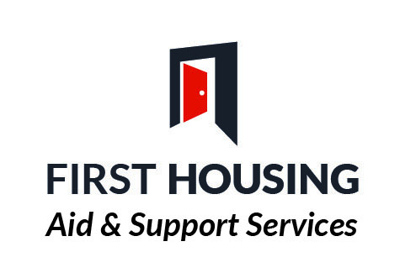Floating Support OLDER PEOPLE 55+
Referral form (Initial Assessment)

PERSONAL DETAILS

Name: Male Female

Current address: Nat Ins No:
Religion:
Marital Status:
Postcode: D.O.B.
Telephone Number:
Mobile Number:
Email address

HOUSING INFORMATION
Details of Accommodation (i.e., Private rental, NIHE, Housing Association etc)

Is your current accommodation suitable to your needs? Yes/No. If No, please explain why?

Housing Points:

Areas of Choice:

Details of others living in this address:

Name | DOB | Relationship to applicant

Applicant’s Housing History (within one year)
Address | NIHE  Private  Hostel etc | Date From | Date To | Reason for Leaving

Details of all professionals involved with the individual

Designation | Name | Address | Tel No

GP
Social Worker
CPN
Counsellor

Other

MEDICAL INFORMATION

Please give details of any mental and physical health disabilities and/or medication _________________________________________________________________________________________________________________________________________________________________________________________________________________________________

INCOME DETAILS

Are you employed? 1 YES 1 NO

Are you in receipt of benefits? 1 YES 1 NO

If yes, please state which benefits ___________________________________________

______________________________________________________________________________________________________________________________________________________

Please indicate daily activities-employment / education /interests etc _________________________________________________________________________________________________________________________________________________________________________________________________________________________________

TYPE OF SUPPORT REQUIRED
Please indicate the type of support required by ticking all the relevant boxes:

Accommodation Issues:

Advice on housing rights and responsibilities

- Sustaining Accommodation

- Finding Alternative Accommodation

- Follow up Support in New Home

- Access to suitable accommodation

- Support to get adaptations / aid for home

Staying Safe:

- Home Security – locks, personal callers

- Home Safety – fire safety, safe use of domestic appliances

- Reporting Repairs

Enjoying and Achieving:
- Life Skills (e.g. advice on making contact with professional, Community Groups)

- Independent shopping

- Advocacy, emotional support, self esteem & confidence building

- Cultural and / or language needs

- Help with building family links

- Encouraging Good Neighbour Relations

- Encouraging involvement in Social Events or Friendship Networks

- Making Contact with professional or community groups

- Accessing Education/Employment / Training

Economic Wellbeing:

Budgeting

- Benefits

- Debt Management

Being Healthy:

- Alcohol issues

- Drug issues

- Other addictions (please give details)
- Support to access Health / Medical facilities

- Advice on home hygiene / cleaning

- Diet, meals on wheels

OFFENDING INFORMATION

Do you have any previous convictions? 1 YES 1 NO

If so, have you ever been convicted of any of the following?
 | YES | NO

OFFENCES AGAINST CHILDREN OR YOUNGPERSON UNDER17YRS

OFFENCES OF A SEXUAL NATURE

OFFENCES OF VIOLENCE

OFFENCES OF THEFT

OTHER

If yes please give details ___________________________________________________ _________________________________________________________________________________________________________________________________________________________________________________________________________________________________

Do you have any pending court cases? 1 YES 1 NO

If yes please give details ___________________________________________________ _________________________________________________________________________________________________________________________________________________________________________________________________________________________________

RISK ASSESSMENT

Does the person present as a risk to themselves or others? 1 YES 1 NO

Please provide details of suicide attempts, self-harm, violence/aggression, ____________________________________________________________________________________________________________________________________________________________________________________________________________________________________________________________________________________________________________

Has applicant got Photographic Identification Y/N

NEXT OF KIN

Name: ___________________________________________________________________
Relationship to applicant___________________________________________________ Address: __________________________________________________________________
Tel: _______________________________________________________________________

Is the Client agreeable to this referral? Yes/No

Client Signature: _________________________________ Date: ___________________

Referral Agent: __________________________________ Date: ___________________

Printed Name: __________________________________ Tel No: __________________

Referral Agent Title & Address __________________________________________________________________________
______________________________________________________________________________________________________________________________________________________

Email Address _____________________________________________________________

Referral Agency: __________________________________________________________

Please forward referral form to:

Anne Blee – Senior Support Worker – Older People Service 55+

First Housing Aid & Support Services, 28A Bishop Street, BT48 6PP

Tel: 02871371849 / 07725688194

email: anneblee@first-housing.com

