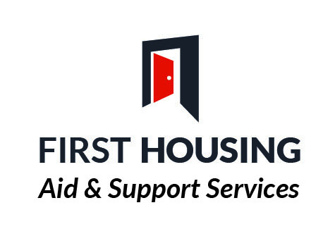Families and vulnerable adults
Referral form (Initial Assessment)

PERSONAL DETAILS

Name: Male ☐ Female☐

Current address: Nat Ins No:
Religion:
Marital Status:
Postcode: D.O.B.
Telephone Number:
Mobile Number:
Email address:

HOUSING INFORMATION
Details of Accommodation (i.e. Private rental, NIHE, Housing Association etc)

Is your current accommodation suitable to your needs? Yes/No. If No, Please explain why?

Housing Points:

Areas of Choice:

Details of others living in this address:

Name | DOB | Relationship to applicant

Applicant’s Housing History (within one year)
Address | NIHE  Private  Hostel etc | Date From | Date To | Reason for Leaving

Details of all professionals involved with the individual

Designation | Name | Address | Tel No

GP
Social Worker
Community Psychiatric
Nurse
Counsellor

Other

MEDICAL INFORMATION

Please give details of any mental / physical health disabilities and/or medication _________________________________________________________________________________________________________________________________________________________________________________________________________________

INCOME DETAILS

Are you employed ? YES NO

Are you in receipt of benefits ? YES NO

If yes please state which benefits ___________________________________________

______________________________________________________________________________________________________________________________________________________

DAILY ACTIVITY

Please indicate daily activities-employment / education /interests

______________________________________________________________________________________________________________________________________________________

TYPE OF SUPPORT REQUIRED
Please indicate the type of support required by ticking all the relevant boxes:

Accommodation Issues:

Advice on housing rights and responsibilities ☐
- Sustaining Accommodation ☐
- Finding Alternative Accommodation ☐
- Follow up Support in New Home ☐
- Access to suitable accommodation ☐
- Support to get adaptations / aids for home ☐

Staying Safe:

- Home Security – locks, personal callers ☐
- Home Safety – fire safety, safe use of domestic appliances ☐
- Reporting Repairs ☐

Enjoying and Achieving:
- Independent shopping ☐
- Advocacy, emotional support, self esteem & confidence building ☐
- Cultural and / or language needs ☐
- Help with building family links ☐
- Encouraging Good Neighbour Relations ☐
- Encouraging involvement in Social Events or Friendship Networks ☐
- Making Contact with professional or community groups ☐
- Accessing Education/Employment / Training ☐

Economic Wellbeing:
- Budgeting ☐
- Benefits ☐
- Debt Management ☐

Being Healthy:
- Alcohol issues ☐
- Drug issues ☐
- Other addictions (please give details) ☐
- Support to access Health / Medical facilities ☐
- Advice on home hygiene / cleaning ☐
- Healthy eating –( meals on wheels etc) ☐
- Exercise (GP referral scheme etc) ☐

OFFENDING INFORMATION

Do you have any previous convictions? YES NO

If so, have you ever been convicted of any of the following?
 | YES | NO

OFFENCES AGAINST CHILDREN OR YOUNGPERSON UNDER17YRS

OFFENCES OF A SEXUAL NATURE

OFFENCES OF VIOLENCE

OFFENCES OF THEFT

OTHER

If yes please give details ___________________________________________________ _________________________________________________________________________________________________________________________________________________________________________________________________________________________________

Do you have any pending court cases? YES NO

If yes please give details ___________________________________________________ _________________________________________________________________________________________________________________________________________________________________________________________________________________________________

RISK ASSESSMENT

Does the person present as a risk to themselves or others YES NO

Please provide details of suicide attempts, self-harm, violence/aggression, ____________________________________________________________________________________________________________________________________________________________________________________________________________________________________________________________________________________________________________

NEXT OF KIN

Name: ___________________________________________________________________
Relationship to applicant___________________________________________________ Address: __________________________________________________________________
Tel: _______________________________________________________________________

CONSENT

Is the Client agreeable to this referral? Yes/No

Has applicant got Photographic Identification Yes/No

Client Signature:_________________________________ Date:____________________

Referral Agent: __________________________________ Date: ___________________

Printed Name: __________________________________ Tel No: ___________________

Title & Address _____________________________________________________________
______________________________________________________________________________________________________________________________________________________

Email Address _____________________________________________________________

Referral Agency: __________________________________________________________

Please forward referral form to:

Yvonne Doherty– Coordinator – Families and Vulnerable Adults

First Housing Aid & Support Services, 28A Bishop Street, BT48 6PP

Tel:

email: yvonnedoherty@first-housing.com

